Project Proposal

**Project Name:** Traces



**Team**:

* Tyrone Jenkins
* Andrew DeLissio
* Phillip Bailey
* Monis Khan
* Vikas Piddempally

**Tagline**: Exploring the surrounding digital footprints.

**Approach**: This app will allow the user to discover what users have tweeted around their location or any location they choose. It is intended to be used by normal people who are curious to know what others in their area are saying. The app will interact with Twitter’s API to extract a tweet’s location information along with the username of the individual that tweeted it and the content of the tweet, and display them in easily consumable formats such as on a Google map. A user of our app will then be able to see what is being said a given location, along with data such as how many times a tweet has been retweeted, the sentiment associated with the tweet, and other things nosey people want to know.

The original concept of this app was loosely based on [Keith Lee's OSINT Stalker tool](https://github.com/milo2012/osintstalker). It was intended to bring greater awareness to users of the dangers of making their social media data publicly available by displaying tweets that other users have made publicly available in the selected area.

**Early Prototypes**:

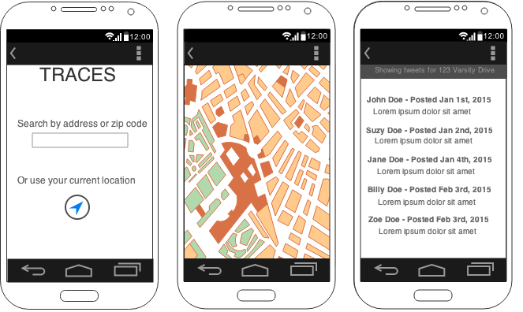

**Grading Milestones**:

|  |  |  |
| --- | --- | --- |
| **Milestone** | **Completion Date** | **Weight** |
| Backend API returns data using coordinates or address | March 17, 2015 | 5% |
| Android app’s user input forms | March 17, 2015 | 15% |
| Basic android app / backend API communication | March 19, 2015 | 5% |
| Return data using date range and radius | March 24, 2015 | 10% |
| Display results in a listview | March 24, 2015 | 10% |
| Google Maps API integration show current location via GPS | March 24, 2015 | 15% |
| Google Maps markers for data points | March 24, 2015 | 15% |
| Lightweight evaluation (interactive prototype) | May 9, 2015 | 10% |
| Long press on map to do search for current point | May 9, 2015 | 15% |
| Backend ranks tweets via favorites and retweet count | May 9, 2015 | 20% EC |
| “Stream” mode for searching via current map locations | May 9, 2015 | 20% EC |
| Color code markers on map by importance | May 9, 2015 | 10% EC |
| Customized icons for map markers | May 9, 2015 | 10% EC |
| Sentiment analysis on tweets | May 9, 2015 | 20% EC |